- cgi
COMMUNICATIONS
2020 Community Video Program

Name: John Giles

Title: Town Manager Address: 11 Poplar Avenue

City, State, Zip: Elsmere, DE 19805 Phone: 302-998-2215

Email: jgiles@townofelsmere.com Website: http://www.townofelsmere.com/

This agreement is between CGI Communications, Inc. ("CGI") and the Town of Elsmere the "Town") and shall remain In effect from the date it is signed by both parties until the third anniversary of the date that the completed and approved Community Video Program is made available for viewer access on different devices via a link on the http://www.townofelsmere.com/ homepage. including any alternate versions of that home­ page.

During the term of this Agreement, CGI shall:
Produce a total of four (4) video chapters with subject matter that includes but is not limited to: Welcome, Education, Healthy Living, Homes I
Real Estate
Provide one Community Organizations chapter to promote charities. nonprofits and community development organizations Provide script writing and video content consultation
Send a videographer to Town locations to shoot footage for the videos
  - Reserve the right to use still images and photos for video production
  - Provide all aspects of video production and editing, from raw footage to final video including professional voiceovers and background music
  - Provide a final draft of Community Video Program content subject to Town's approval (up to 3 sets of revisions allowed). CGl's request for approval of content or revision. including final draft, shall be deemed approved if no response is received by us within 30 days of request
  - Provide our patented OneClick™ Technology and encode all videos into multiple streaming digital formats to play on all computer systems, browsers, and Internet connection speeds; recognized player formats include WindowsMedia 'Mand QuickTime'M
  - Store and stream all videos on CGl's dedicated server
  - Feature business sponsors around the perimeter of video panels
  - Be solely responsible for sponsorship fulfillment including all related aspects of marketing, production, printing, and distribution
  - Facilitate viewer access of the Community Video Program from Town website, including any alternate versions of Town's homepage, for different devices, by providing HTML source code for a graphic link to be prominently displayed on the http"/lwww townofelsmere com/ website homepage as follows: "Coming Soon" graphic link designed to coordinate with existing website color theme to be provided within 10 business days of execution of this agreement. "Community Video Program" graphic link to be provided to replace the "Coming Soon" link upon completion and approval of videos
  - Grant to Town a license to use CGl's Line of Code to link to and/or stream the videos
  - Own copyrights of the master Community Video Program
  - Assume all costs for the Community Video Program
  - Afford businesses the opportunity to purchase various digital media products and services from CGI and its affiliates

Program add-on:
  - CGI will provide the finished video chapter files to the Town for use on the local cable access channel, FaceBook and lnstagram. Finished videos will include the CGI logo at the end of each video and may only be used during the term of this agreement. The Town must submit a request in writing to use the files for any other purpose than listed in this agreement.

During the term of this Agreement, the Town shall:
  - Provide a letter of introduction for the program on Town's letterhead
  - Assist with the content and script for the Community Video Program
  - Grant CGI the right to use Town's name in connection with the preparation, production, and marketing of the Program
  - Display the "Coming Soon" graphic link prominently on the http://www.townofelsmere.com/ homepage within 10 business days of receipt of HTML source code
  - Display the "Community Video Program" link prominently on its http://www townofelsmere com/ homepage, including any alternate versions of your home page, for viewer access on different devices for the entire term of this agreement
  - Ensure that this agreement remains valid and in force until the ag=reed upon expiration date, regardless of change in administration
  - Grant full and exclusive streaming video rights for CGI and its subsidiaries, affiliates, successors and assigns to stream all video content produced by CGI for the Community Video Program
  - Agree that the town will not knowingly submit any photograph, video, or other content that infringes on any third party's copyright, trademark or other intellectual property, privacy or publicity right for use in any video or other display comprising this program.

This Agreement constitutes the entire agreement of the parties and supersedes any and all prior communicat ions, understandings and agreements, whether oral or written. No modification or claimed waiver of any provision shall be valid except by written amendment signed by the parties herein. Town warrants that it is a tax exempt entity. The undersigned, have read and understand the above information and have full authority to sign this agreement.
Town of Elsmere, DE CGI Communications, Inc.

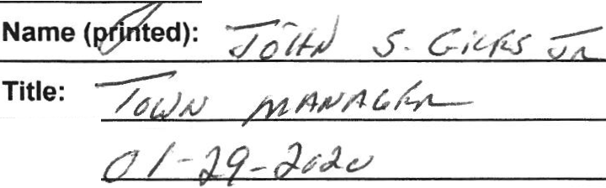Signature:
Date:

Name (printed): Nicole Rongo

Title: Vice President of Marketing and Acquisitions Date: January 29, 2020

IllCOMMUNICATIONS

130 East Main Street, 5th Floor Rochester, NY 14604

Phone: 800.398 .3029
Fax: 585.653.7393

