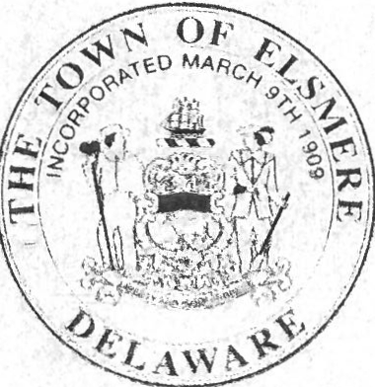
!!l!1/YDMmbm
&3-01
HONORING MR. JOHN S. GILES JR FOR HIS 40 YEARS OF SERVICE TO THE TOWN OF ELSMERE
WHEREAS, on Sunday, December 18, 2022, the Mayor and Council learned of the untimely passing of Mr. John
S. Giles, Jr., 63, of New Castle, Delaware; and

WHEREAS, Mr. Giles was born and raised as a resident of Elsmere and served the residents as a member of the Elsmere Fire Company for 50 years; and

WHEREAS, Mr. Giles began his employment with the Town of Elsmere on November 21, 1978 as a member of the Department of Public Safety, where he worked his way up through the ranks and was ultimately named Chief of Police on July 1, 1994 before retiring from the Department on November 21, 1998.

WHEREAS, in March of 1997 while serving as Chief of Police, following the sudden departure of the Town Manager, Mr. Giles stepped up and performed the duties of both Town Manager and Chief of Police until March of 1998; and

WHEREAS, In 2002, the Town was again in need of new management and John answered the call to serve and was hired as Town Manager on November 18, 2002; and

WHEREAS, during his career as Town Manager, Mr. Giles was an active member of the City Managers Association of Delaware (CMAD) and served on the Delaware League of Local Governments (DLLG) Legislative Advocacy Committee to review laws proposed in the State Legislature which would affect municipalities ; and

WHEREAS, in 2014 Mr. Giles was nominated by the Mayor and Council of the Town of Elsmere for the Town Manager of the Year Award given by the Delaware League of Local Governments and was ultimately selected from a group of statewide nominees as the recipient and 2014 Town Manager of the Year; and

WHEREAS, Mr. Giles served the residents of the Town of Elsmere as Town Manager until November 2022, when he retiredfrom the Town after having served the residents as an employee of the Town for a combined 40 years of service; and

WHEREAS, The Mayor and Council wish to publicly acknowledge the dedication and service that Mr. Giles provided to the Town of Elsmere and its residents, as well as, the sacrifices that his family made while allowing him to give so much of his time and himself to the service of others.

NOW, THEREFORE, the Mayor and Council hereby join together to pay tribute and to recognize former Chief of Police and Town Manager, Mr. John S. Giles, Jr. The Mayor and Council also wish to acknowledge Mr. Giles ' commitment to doing the right thing for the residents of the Town of Elsmere, while serving the Town as a member of the Elsmere Fire Company, the Elsmere Bureau of Police and as Town Manager.

RESOLVED BY THE MAYOR AND COUNCIL OF THE TOWN OF ELSMERE, THIS 121
h
DAY OF

aJANUA·RY 2023.
Eric Scott Thompson
Mayor

&

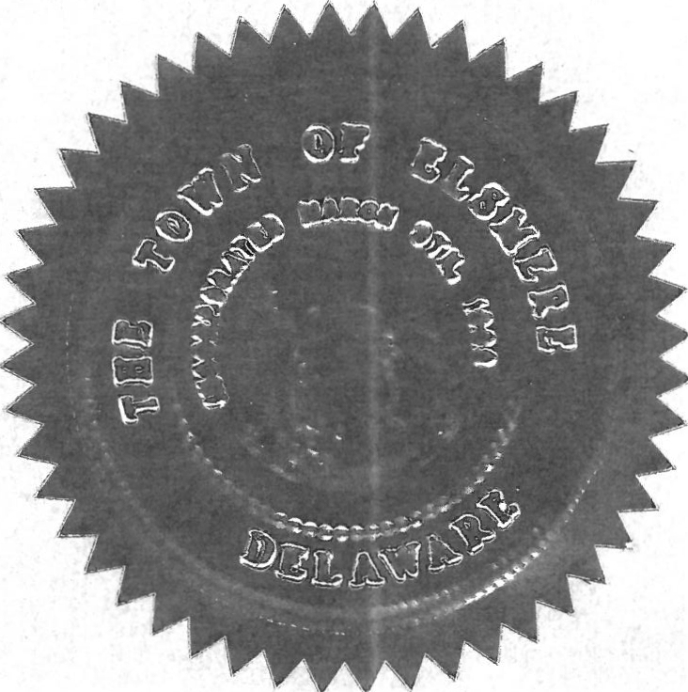
. Sally Jensen
Secretary of Council

