Town of Elsmere
2024-2025
Tax Year

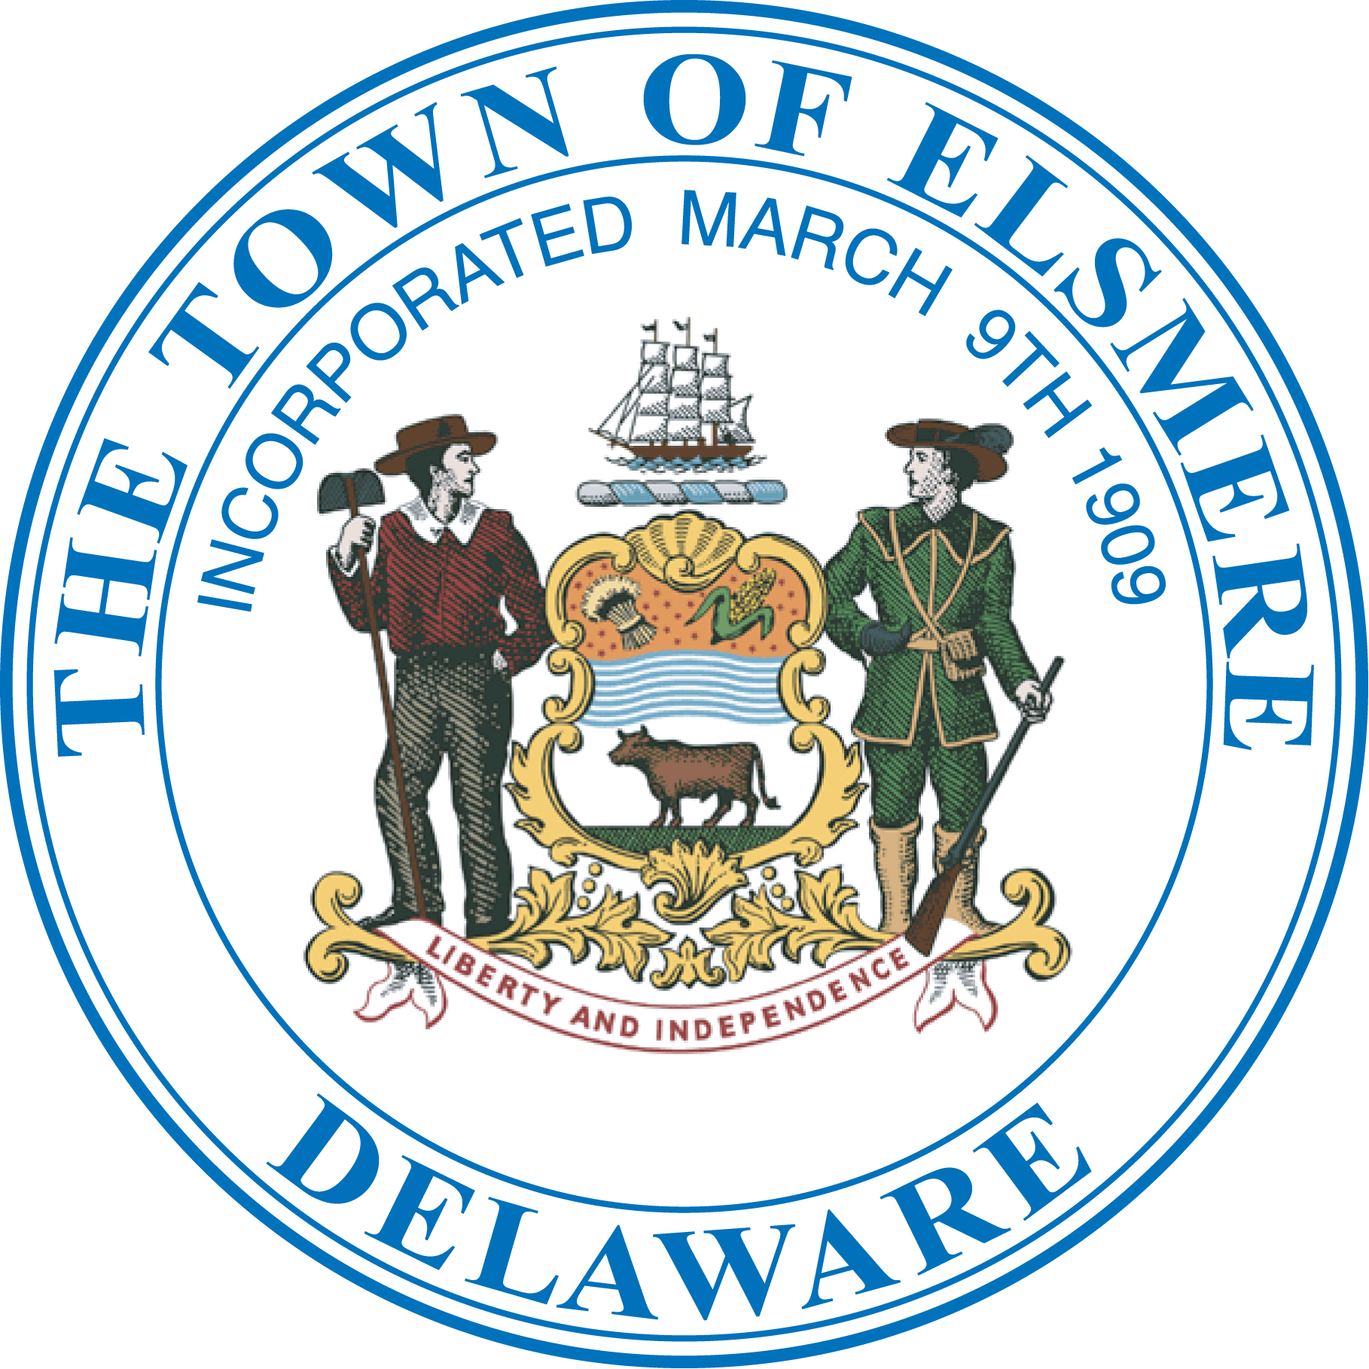

SENIOR / DISABLED
Property Tax Discount

Application

QUALIFICATIONS, FOR THE SENIOR / DISABILITY EXEMPTION

QUALIFICATIONS:

To be eligible for the exemption offered by the Town, you must meet the following qualifications:

- You must have reached the age of 65 or have been disabled on or before July 1, 2024.

- You must have been a resident of the Town of Elsmere since at least December 31, 2020.

- You or you and your spouse, must be the legal owner(s) of the property for which the exemption is being sought.

- You must reside in the residence for which the property tax exemption is being sought.

- For single applicants, your TOTAL SINGLE HOUSEHOLD INCOME during the calendar year beginning January 01, 2023 and ending December 31, 2023 must not exceed $24,500.

- For applicants who are a couple or family, your TOTAL HOUSEHOLD INCOME during the calendar year beginning January 01, 2023 and ending December 31, 2023 must not exceed $30,000.

- You must submit your completed application, including all supporting documents, to the Finance Department for approval by the Town Manager on or before May 01, 2024.
Applications will not be accepted after May 01, 2024.

H. For those who have a joint ownership with a non-spouse but otherwise meet the requirements, there is a proportional share of the exemption available.

I. All prior years taxes and associated fees must be paid in full.

DEFINITIONS FOR THE SENIOR DISABILITY EXEMPTION

DEFINITIONS:

The terms used in this application shall have the following definition:

Blindness:

Means central visual acuity of 20/200 or less in the better eye with the use of a correcting lens. An eye which is accompanied by a limitation in the fields of vision such that the widest diameter of the visual field subtends an angle no greater than 20 degrees shall be considered for purposes of this definition as having a central visual acuity of 20/200 or less.

Disabled:

A person who is unable to engage in any substantial gainful activity by reason of any medically determinable physical or mental impairment which can be expected to result in death or has lasted or can be expected to last for a continuous period of not less than 12 months, or blindness.

Household Income:

The income as defined in the “Income” definition of this chapter must include the income of each and every person residing in the residential property for which the application has been made, regardless if they are related or not, married or not, children or not, contributing to the household or not.

Income:

All income from whatever source derived, including but not limited to realized capital gains and, in their entirety, pension, annuity and retirement benefits, as defined herein for any tax year for which an exemption is claimed, "income" shall be determined to be equal in amount to the income received during the calendar year or the taxpayer's fiscal year ended immediately preceding December 31 of the pretax year, but no taxpayer shall use a fiscal-year basis, unless they elects to do so, and file their federal income tax return on such basis.

Specifically exclude from being calculated as income shall be any income received as a benefit from the Social Security Act, and disability benefits for those persons “disabled" as well as any income received as a benefit from any Railroad, Police or Fire Department pension plan.

Resident:

One legally domiciled within the Town of Elsmere for a period of three years immediately preceding December 31 of the pretax year. Mere seasonal or temporary residence within the Town of Elsmere of whatever duration shall not constitute domicile within the Town for the purposes of this article. Absence from this Town for a period of 12 months shall be prima facie evidence of abandonment of domicile in this Town. The burden of establishing legal domicile within the Town shall be upon the claimant.

Single Household Income:

The income as defined in the “Income” definition of this chapter of a single person residing
alone in the residential property for which the application has been made.

INSTRUCTIONS FOR THE SENIOR/ DISABILITY EXEMPTION

APPLICATION

- You must complete the application in full including all necessary signatures.

- You must attach all required documents.

- If you filed a federal tax return you must attach a copy of your federal return with this application.

- If you did not file a federal tax return, you must attach copies of your statements of pension income if not specifically excluded and/or interest income received.

- Should additional information be required, it is your responsibility to comply with all requests for additional information.

- Applicants who are disabled must submit a copy of their Certificate of Social Security Insurance Award and have a physician’s signature certifying the extent of their disability.

G. If your exemption is denied, you may appeal the decision of the Town Manager to the Town of Elsmere Mayor and Council.

H. You will be required to establish your income annually for the purpose of continuing the exemption. It is your duty to report to the Finance Department any change of your status or of property, which effects the exemption or your right to it.

I. You must return the completed application, including all required documents, to the Finance Department for approval by the Town Manager no later than May 1st, 2024.

Tax Year 2024/2025

Senior / Disabled Tax Exemption

APPLICATION FOR TAX PARCEL

First Name: _________________________ Last Name______________________________ Middle Initial:_____ Suffix:______

Applicants Name

Number: ________________Street :___________________________________________________________________________

Street Address

Month: ____________ Day: _______Year:_________

Your Date of Birth

Marital Status

Married Single / Divorced Widow

First Name: _____________________________ Middle Initial: _______ Date of Birth: Month _________ Day____ Year______
Spouses Information

Co-Habitant Information: (Provide the following information for each person residing in your home)

First Name | Last Name | Date of Birth | Relationship

YOUR INCOME INFORMATION

Income From | Applicant | Spouse | Other | Other
Salaries, Wages, Tips
Pensions (Excluding Railroad, Police or Fire Department pension)
Interest / Dividends
Rental Income
Disability Benefits
Other (Describe)
Other (Describe)
Other (Describe)
Total of Each Colum | $ | $ | $ | $
Total Income (Add together the total of each column) |  |  |  | $

YOU MUST ANSWER EACH OF THE FOLLOWING QUESTIONS

 | Yes | No
Do you reside in the residence for which you are applying for the tax exemption?
Have you lived in the town of Elsmere since at least December 31, 2020?
Are you required to file a Federal Tax Return for the year ending December 31, 2023?
If yes you must attach a copy of your Tax Return to your application. Is a copy attached?
If you are applying because of a disability, you must have your doctor submit a certificate of disability to this application. Is the original certificate from your doctor attached?

Applicants Oath
I hereby swear or affirm that the information provided in this application is true and correct to the best of my knowledge and belief and that I am fully aware that any misrepresentation by me either intentionally or otherwise may result in my being denied the tax break sought in this application as well as any future application and that I may be liable for any tax break that had been granted in the past. I further acknowledge that it is my responsibility to keep the Town of Elsmere and specifically the Town Manager informed should any of the information in this application change.

__________________________ _______________ ___________________________
Applicants Signature Date Phone Number

__________________________ _______________ ____________________________
Co- Applicant Signature Date Email Address

FOR OFFICIAL USE ONLY NOT TO BE COMPLETED BY THE APPLICANT
Date the application was received by the Town: ________________________________

Employee receiving the application: _________________________________________

Assessed Value of the Property: _________________ Exemption Approved: _____________

Date the application was reviewed by the Town Manager: ______________________________

Action by the Town Manager: ______Approved _______Denied _______ Partial Approval

Town Managers Signature: _____________________________________________

Date the approval or partial approval was entered into the tax system: ________________

Comments: ______________________________________________________________________________
______________________________________________________________________________
______________________________________________________________________________
______________________________________________________________________________
______________________________________________________________________________

Town of Elsmere
Certificate of Disability

I, ___________________________________________ hereby acknowledge that I have
(Physicians Name)
reviewed the below portion of the Code of the Town of Elsmere Article III Section 204-10,
this defines “Disabled” as:

“A person who is unable to engage in any substantial gainful activity by reason of any medically determinable physical impairment or mental impairment, which can be expected to result in death or has lasted or can be expected to last for a continuous period of not less than 12 months, or blindness; and the term “blindness” means central vision acuity of 20/200 or less in the better eye with use of a correction lens. An eye which is accompanied by a limitation in the field of vision such that the widest diameter of the visual field subtends an angle no greater than 20 degrees shall be considered for the purpose of this definition as having a central vision acuity of 20/200 or less.”

I have examined my patient _______________________________ and have found in my
Applicants Name
professional opinion, their medical or mental condition falls within the definition of “Disabled” as defined by the Code of The Town of Elsmere.

_______________________________
Physicians Name (Printed)

_______________________________

_______________________________ ______________________________
Physicians Signature
_______________________________
Physicians Address (Printed) ______________________________
Date Signed

(____)____________________________
Physicians Phone Number

