Town of Elsmere
2025-2026
Tax Year
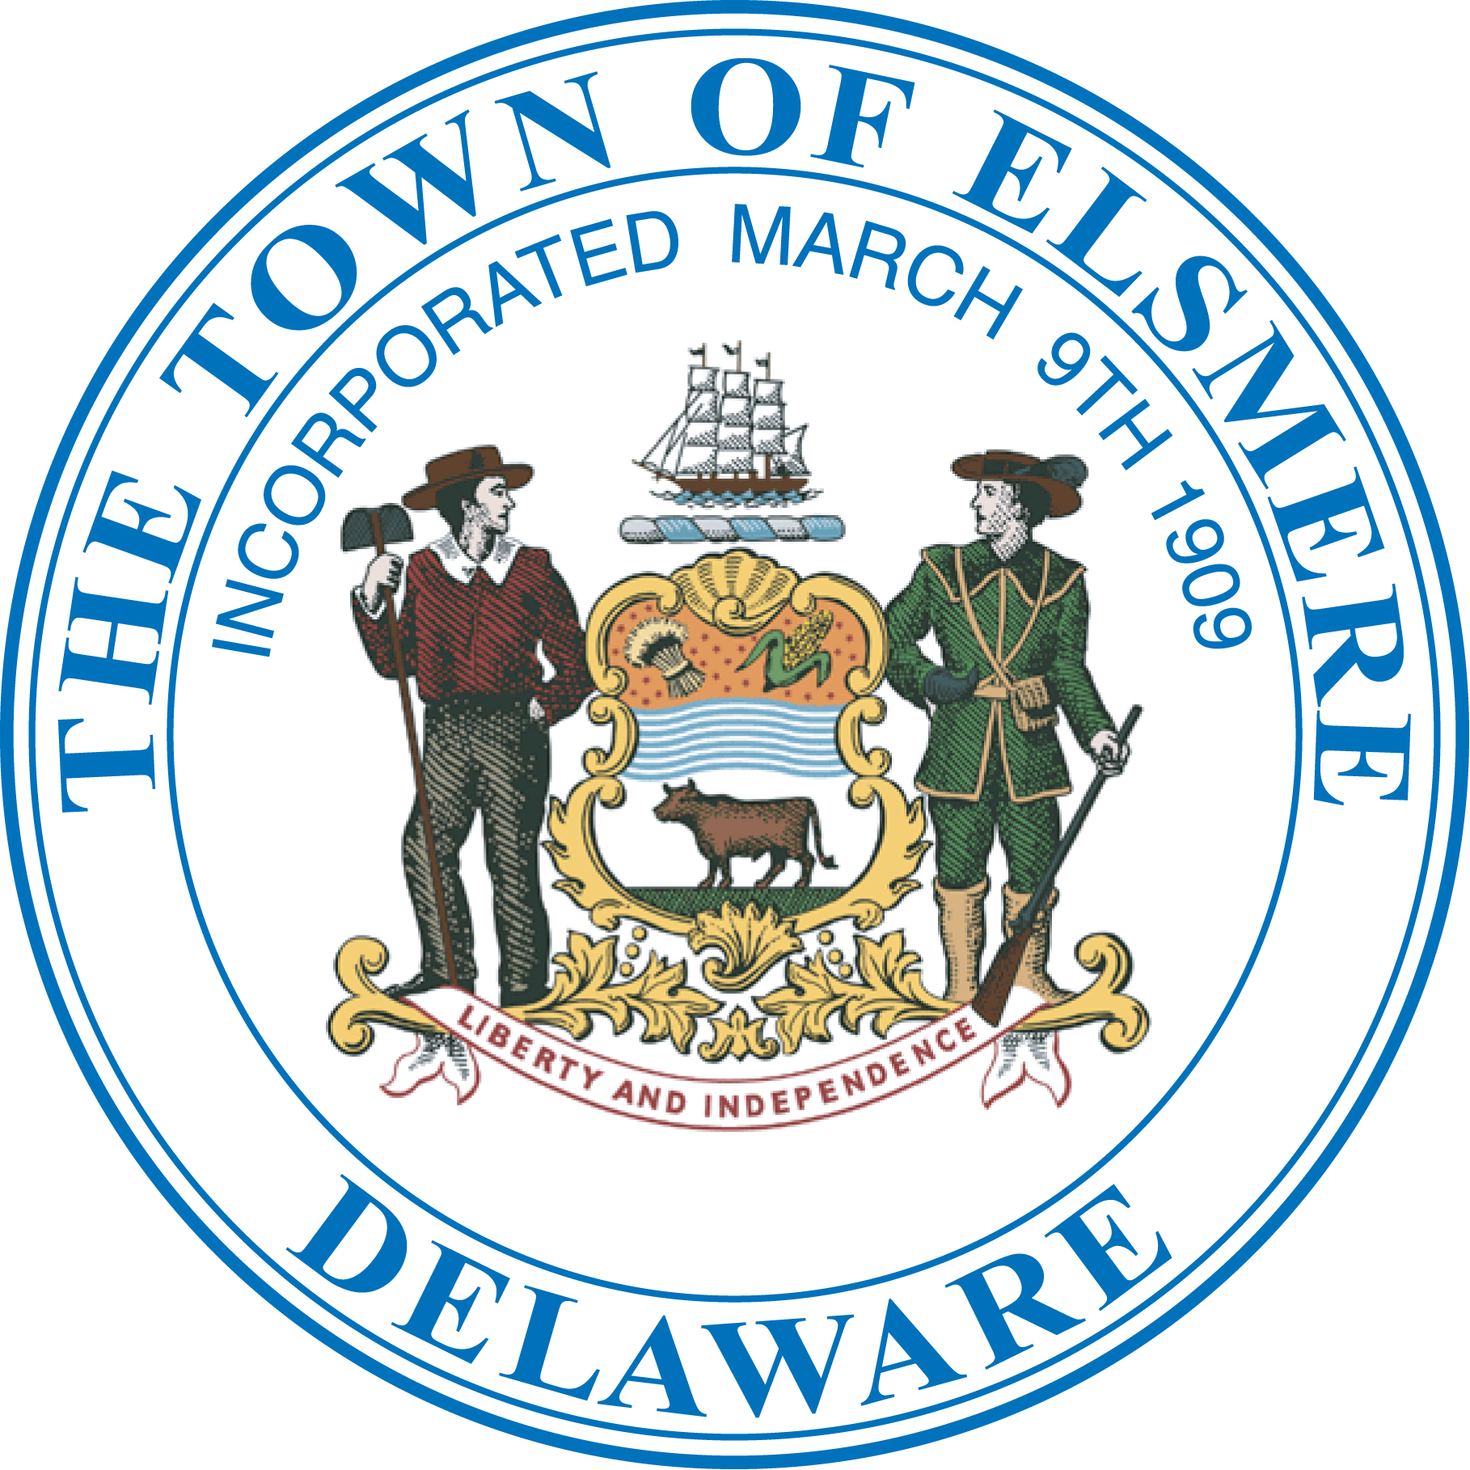

SENIOR / DISABLED
Property Tax Discount

Confirmation of Eligibility

You are receiving this form because you had been approved to receive the Town of Elsmere’s Property Tax Discount during the Town’s 2025-2026tax year. To continue receiving this discount on your property taxes, you MUST complete the attached form which acknowledges that you are still qualified to participate in this program. If you do not return the attached form to town hall by the required date you will not receive the property tax discount in the upcoming year. If you have questions or need assistance in completing this form please contact Miss. Jackie Moore in the Finance Department at (302) 998-2215.

INSTRUCTIONS FOR THE SENIOR/ DISABILITY EXEMPTION

CONFIRMATION

- You must complete the confirmation in full including all necessary signatures.

- If there are any changes to the household you must disclose those changes.

- If you did not file a federal tax return, you must attach copies of your statements of pension income if not specifically excluded and/or interest income received.

- If you filed a federal tax return you must attach a copy of your federal return with this application.

- Should additional information be required, it is your responsibility to comply with all requests for additional information.

- If any additional persons has moved into the residence during the 2024 calendar year you must include their income.

- You must return the completed confirmation, including all required documents, to the Finance Department for approval by the Town Manager no later than May 1, 2025.

- If your exemption is denied, you may appeal the decision of the Town Manager to the Mayor and Council.

Town of Elsmere Senior/Disabled Tax Credit

Confirmation of Eligibility for the 2025/2026 Tax Year

I ____________________________________________________________________ of
(Print Your Full Name)

__________________________________________ hereby certify to
(Print Your Complete Home Address) Phone Number

The Town of Elsmere that I am still eligible to receive the Senior / Disabled tax exemption offered by the Town because I am over the age of 65 and or disabled and that,

- As a single applicant, my TOTAL HOUSEHOLD INCOME during the calendar year beginning January 01, 2024 and ending December 31, 2024 did not exceed $24,500 or;

2. As a couple or family applicant, our TOTAL HOUSEHOLD INCOME during the calendar year beginning January 01, 2024 and ending December 31, 2024 did not exceed $30,000 and;

3. All property taxes and /or code citation due to the Town are paid in full.

4. There have been no changes in the HOUSEHOLD IN THE LAST YEAR.

Provide the following information for each person residing in your home

First Name | Last Name | Date of Birth | Relationship

I hereby swear or affirm that the information provided in this confirmation of eligibility is true and correct to the best of my knowledge and belief, and that I am fully aware that any misrepresentation by me either intentionally or otherwise may result in my being denied the tax exemption sought in this confirmation, as well as any future application and that I may be liable for any tax exemption that had been granted in the past. I further acknowledge that it is my responsibility to keep the Town of Elsmere and specifically the Town Manager informed should any of the information in this confirmation of eligibility change.

__________________________ _______________ ___________________________
Applicants Signature Date Phone Number

__________________________ ______________ ___________________________
Co-Applicants Signature Date Email Address

Are you currently in the process of or completed a Reassessment Hearing with NCC ? Yes Or No

You must submit this confirmation of eligibility to the Finance Director via the Finance Department on or before May 1, 2025.

FOR OFFICIAL USE ONLY NOT TO BE COMPLETED BY THE APPLICANT
Date the application was received by the Town: ________________________________

Employee receiving the application: _________________________________________

Assessed Value of the Property: _________________ Exemption Approved: _____________

Does application qualify for additional Base Tax Credit ______Yes ______No

______60% ______35%

Date the application was reviewed by the Finance Director: ______________________________

Action by the Finance Director: ______Approved _______Denied _______ Partial Approval

Finance Director Signature: _____________________________________________

Date the approval or partial approval was entered into the tax system: ________________

Comments: ______________________________________________________________________________
______________________________________________________________________________
______________________________________________________________________________
______________________________________________________________________________
_____________________________________________________________________________

